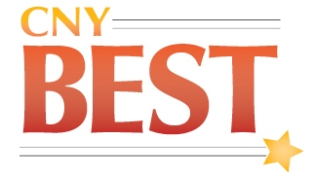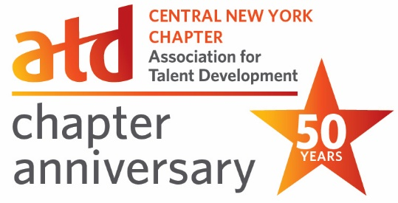

16th Anniversary CNY BEST Talent Development Awards

The winners of the 16th Anniversary CNY BEST Talent Development Awards were announced at CNY ATD’s CNY BEST Talent Development Awards Ceremony on Wednesday, November 1, 2023 at the DoubleTree by Hilton Hotel Syracuse.

CNY ATD annually presents the CNY BEST Talent Development Awards to recognize excellence in talent development in the Central New York area. Organizations that link talent development to the strategic growth or success of organizations and individuals are recognized as CNY's BEST in Talent Development.

Nominations for this year’s CNY BEST Talent Development Awards represent a wide-range of organizations and include: Assured Information Security (AIS) and New Horizons at Logical Operations, AmeriCU Credit Union, BITZER Scroll, Chick-fil-A Restaurants, Cliff's Local Market, Community Bank, N.A., Emergent LLC, Lifestyle Growth, MACNY - The Manufacturers Association, NBT Bank Talent and Organizational Development Team, Oswego County Federal Credit Union, Pam Gavenda, SPHR, Syracuse University, Perspective Mentoring, Suburban Propane, and VIP Structures.

Nominations were evaluated by a panel of local and national judges representing the profession and community. They evaluated the quality of talent development practices, practice results and impacts, and demonstrations of how the practices linked to the strategic growth or success of organizations and individuals.

CNY BEST Talent Development For Consultant
Emergent was recognized with the CNY BEST Talent Development For Consultant Award for linking talent development to their organization’s strategic growth or success with their Emergent Leader program.

The public Emergent Leader course is a remote offering that consists of five three-hour sessions, four one-on-one coaching meetings, and one post-course “action learning” session. Participants receive a workbook as an instructional aid. The course is built around five fundamentals of leadership. The first five sessions deal with each of these fundamentals: Leadership Presence; Communicating Clearly; Leadership Agility; Building Teams; and Driving Performance.

CNY BEST Talent Development Team
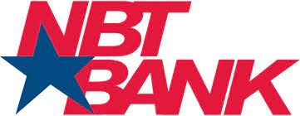
NBT Bank was honored with the CNY BEST Talent Development Team Award for linking talent development to the organization’s strategic growth or success with its Employees Crave Skills: Keys to a Successful Learning Platform Rollout.

Amid the Covid-19 pandemic, NBT Bancorp's organizational development team adapted to better support employee growth. They aimed to shift towards an ongoing skill development model to accommodate the company's geographical expansion during the pandemic, address employee engagement concerns, and mitigate knowledge loss from retirements. They initiated a learning-specific survey to identify needs and found that providing on-demand content was the optimal solution. With the introduction of their new HRIS platform, including the internally branded NBT University, the team partnered with a content vendor to offer on-demand skill development resources. This empowered employees to develop their skills at their convenience, regardless of location, resulting in widespread platform adoption with activation rates surpassing those of similar organizations.

CNY BEST Talent Development for Non-Profit
Oswego County Federal Credit Union was presented with CNY BEST Talent Development Consultant Award for linking talent development to a client’s or clients’ strategic growth or success with its Leadership and Personal Development.

The purpose of the program is to meet the needs of our employees as we navigate through rapid growth and staff changes. This forced increased pressure on all levels of management as well as the increased staff stress due to staffing issues and COVID fatigue, we were in need of leadership training and self-awareness training. This program consisted of DISC Assessment and Debrief, Personal Development Training, Communication Workshops, Servant Leadership Sessions, Teamwork Sessions, Team Assessment Leadership Game and Personal Development Sessions. All sessions are designed to encouraged to create honest and full communication, team building, basic and in-depth training, learning perspective, and creating next step solutions for all levels of leadership, organization and Community engagement. Employees have gained a better understanding of themselves, their strengths and weaknesses, how they communicate, and the importance of taking time for personal growth. The morale at the organization has improved dramatically and staff is much more engaged.

CNY BEST Talent Development For-Profit

VIP was presented with CNY BEST Talent Development Consultant Award for linking talent development to a client’s or clients’ strategic growth or success with its Leading @VIP: Changemakers Speakers Series 2023.

The VIP enterprise is an integrated Design-Build firm consisting of architects, engineers, and builders, who work together to perfect our design-build craft to deliver exceptional quality and craftsmanship to our clients in and outside of our homebase of Syracuse. Employee retention and development are key to the organization’s growth. Formed in 2020, Leading @VIP is the enterprise leadership development platform, an integrative approach to talent development focusing on Business Leadership Development and Emerging Leader Upskilling. In 2023, the post-pandemic workforce required a comprehensive solution and Community Engagement was added as the third prong to this integrative development platform. We knew from societal shifts and employee feedback, we needed to bridge our organization in the greater community in a more meaningful way to truly enrich our organizational culture. Focusing on Community Engagement, Leading @VIP Changemakers Speaker Series, showcases business leaders who promote positive change, equity, justice, and empower marginalized groups. The speakers invited are women who are agents of change within their own organization or community. The series format is that of a fireside chat which aims to provoke experiential stories alongside direct and practical advice through a conversational style. The aim is to offer VIP employees a deeper relationship with the Syracuse community so they may identify how they can make change in the organization and community.

CNY ATD Scholarship Awards
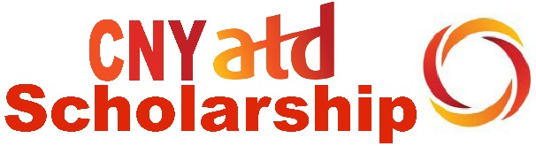
Serena Jackson, InterFaith Works, Stacy Miller, Merit Apprenticeship Alliance and Sue Odell, OneGroup were awarded CNY ATD Train-the-Trainer Scholarships to attend the nationally-recognized CNY ATD Train-the-Trainer Program.

CNY ATD established the CNY ATD Scholarship Program to encourage and support professional development and continuing education in the field of talent development. The CNY ATD Train-the-Trainer Scholarships provide financial assistance for nonprofit organizations looking to develop their staff or volunteers who educate an audience.

Keynote Speaker
The keynote speaker for the CNY BEST Talent Development Awards Ceremony was Kirk Wolfgang, Director of Facilities and Engineering at Lotte Biologics.

Sponsors
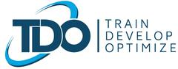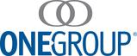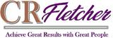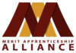
CNY ATD thanks the following sponsors for their support of the CNY BEST Talent Development Program: TDO - Train, Develop, Optimize; CNY Business Journal; OneGroup, AmeriCU Federal Credit Union, Emergent, CR Fletcher, Merit Apprenticeship Alliance and National Grid.

----------------------------------------------------
For questions regarding this announcement, please contact managingdirector@cnyatd.org or 315.762.3464.

About CNY BEST Talent Development Program
CNY ATD annually recognizes excellence in talent development in the CNY area with the CNY BEST Talent Development Program. Organizations, consultants and individuals/teams who have made an impact on the success of the organizations and communities they serve are recognized as CNY's BEST in Talent Development. Nominated practices represent a diverse variety of talent development topics and techniques. A panel of local and national judges representing the talent development profession and community evaluate the nominations for quality of talent development practices, practice results and impacts, and demonstrations of how the practices linked to the strategic growth or success of the organization and individuals. CNY ATD has been nationally recognized for this innovative CNY BEST Program which “creates awareness in the community about talent development and its importance to organizational success, while creating involvement by organizations in the community through recognition of excellence in talent development practices”. CNY ATD is celebrating the 16th Anniversary CNY BEST Talent Development Program in 2023.

About the CNY ATD Scholarship Program
CNY ATD established the CNY ATD Scholarship Program to encourage and support professional development and continuing education in the field of talent development. Since its inception in 2011, the CNY ATD Scholarship Program has awarded over $18,000 in monetary assistance to industry professionals and students pursuing various talent development programs. CNY ATD has been nationally recognized for its CNY ATD Scholarship Program which “addresses a need in the local community for financial support for talent development professionals to pursue professional development and continuing education.”

About CNY ATD
CNY ATD is the local affiliate chapter of Association for Talent Development (ATD). Celebrating its 50th Anniversary, CNY ATD has been connecting talent development professionals throughout the region and contributing to the growth and recognition of the profession. Currently, CNY ATD has over 120 members from various businesses covering the central part of New York State from the North Country to the Southern Tier and from the Seneca-Cayuga Corridor to the Mohawk Valley. CNY ATD is proud to have received numerous national and local recognitions, including 22 ATD recognitions over the past 16 years.

CNY ATD
PO Box 6343
Syracuse, NY 13217-6343
315.762.3464
managingdirector@cnyatd.org

